EENG 3920: Modern Communication Systems Design

# **Lab 3: Frequency Spectra of Popular Waveforms**

Group 5

Victor Rodriguez (victorcuba92@gmail.com)

Mohammad Qawash (MohammadQawash@my.unt.edu)

John Rolfe (JohnRolfe@my.unt.edu)

Natalie Powers (NataliePowers@my.unt.edu)

Nathan Ruprecht (nathan.ruprecht@outlook.com)

**Date of Submission: 3 March 2016**

**Section 1**

**Introduction and Learning Objective**

EENG 3920 is the project design course for electronics courses. Students are required to design electronic communication systems with electronic devices such as MOS transistors, capacitors and resistors. The design and simulation tool is NI ELVIS platform. Topics include LC circuits and oscillators, AM modulation, SSB communications, and FM modulation. At the end of the class, the student should be able to: Understand fundamental concepts and circuits used in communication systems; Describe principles and theory of various communication techniques such as AM, FM, and SSB; Conduct effective analysis and interpretation of the experiments; Demonstrate the ability to identify, analyze, and solve technical problems; Creatively apply the course topics to designs; Simulate and analyze advance electronics circuits with NI ELVIS instruments and other test equipment.

For this experiment we investigated the behavior of a negative clamper, studied class C bias and amplification, and understood the theory of frequency multiplication.

**Safety guidelines**

As mentioned in the lab procedures, safety is extremely important in the lab. In the event of electrical fire, the session 1 lecture note states to use the fire extinguisher, located at the front of the lab, then to vacate the lab, close the door and ring the fire alarm.

**Section 2 / 3**

**Theoretical Background**

There are two parts to understand this lab. The first portion dealt with negative clamping of class C amplifiers. The point was to recognize that at certain values of a sine wave, the transistor would turn on and draw the voltage down. The second portion deals with frequency multiplication. The point is to figure out the resonance frequency of a given circuit, finding the -3dB of each side if it applied, and using that to find the frequencies to input in order to multiply the output by a given magnitude.

**Exercises**

Procedure:

For the first part we built the first circuit, applied a source voltage and frequency, and graphed the input and output signals. From this we were able to determine the critical level, which we got as 2V.

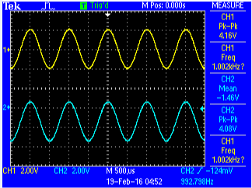

In the second part, we started dealing with negative clamping of a class C amplifier. So we again built the given circuit and applied a test voltage and at certain frequencies. With varying test source, we saw different effects on the output signal. At first, we saw a DC output at 12V. As we increased the peak-to-peak voltage supply, we saw a decrease in DC offset which led to a bigger drop in the clamping of the output signal.

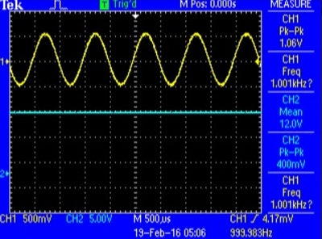

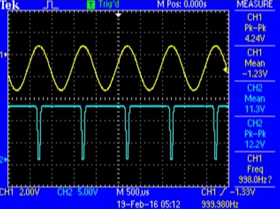

Measuring the time length of the clamp, as well as the period of the signal, we were able to determine the duty cycle of each test voltage.

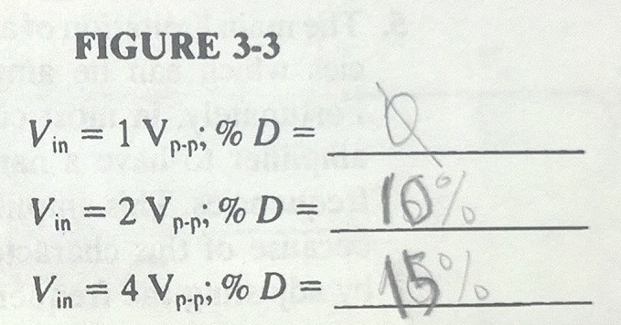

Next we built another circuit. The point of this next part was to observe frequency multiplication. We applied a test voltage and frequency and saw the output signal scaled to a certain factor. From there, we found the frequency that outputted a max voltage. Using this as a center frequency, we found the 3dB drop-off on either side of that frequency.

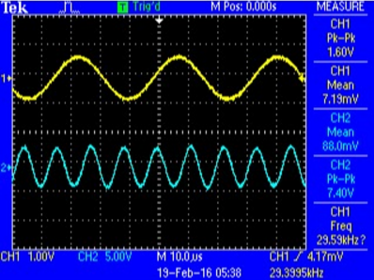

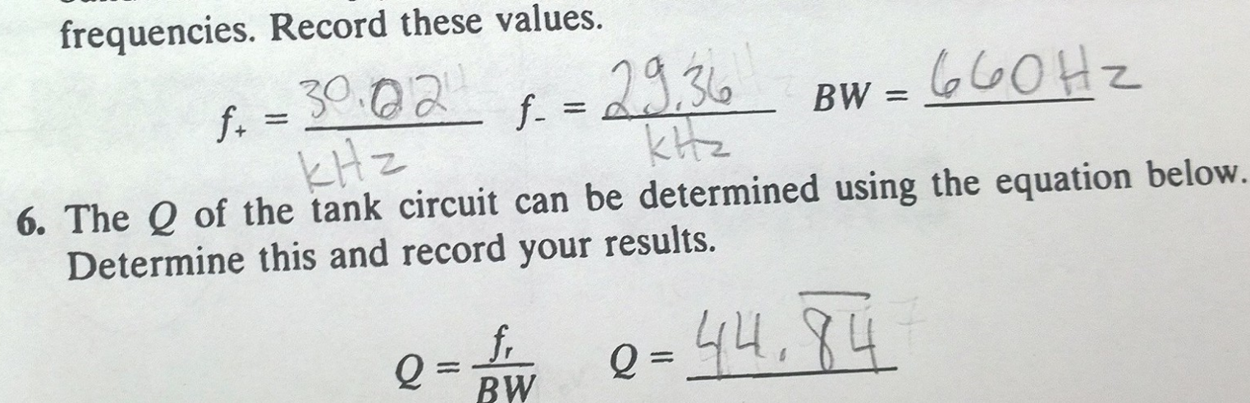

The next portion of the lab demonstrated the flywheel effect. We followed instructions for frequency multiplication before, but now we are free to adjust the parameters to get a multiplication factor of 3, 4, and 5. We recorded all that data to show our results and success.

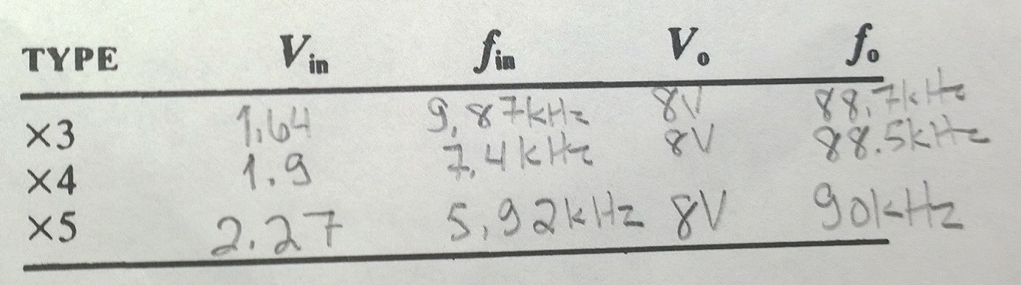

**Section 4**

**Conclusion**

In this lab, we understood the two parts that were discussed in the theoretical background. The first portion dealt with negative clamping of class C amplifiers. The point was to recognize that at certain values of a sine wave, the transistor would turn on and draw the voltage down. The second portion deals with frequency multiplication. The point is to figure out the resonance frequency of a given circuit, finding the -3dB of each side if it applied, and using that to find the frequencies to input in order to multiply the output by a given magnitude.

Follow Up Questions:

1. We put the diode in a RC circuit, and increased the peak-to-peak voltage source until the DC offset of the output was below the input. At a certain value of the sine wave, the transistor would turn on. So at every other point, the output is the DC value.
2. It’s a very predictable circuit in that we know that at a certain value of the sinusoid, the output dips down to near zero. It’s disadvantageous in that it’s either working or not working, on or off.
3. We set the frequency of the input to one-third of the resonance frequency of the circuit. That should output the desired frequency multiplied by a given factor. A single stage multiplier for 7 is hard because the window is very small since the frequency is so close to that of a 6 or 8 multiplier. Whereas it’s a large window for that of a times 3 multiplier.

# **References**

Agilent Technologies, 2007, *Agilent 34401A 6 ½ Digit Multimeter, User’s Guide*.